From your Windows laptop, Image the SD Memory card.
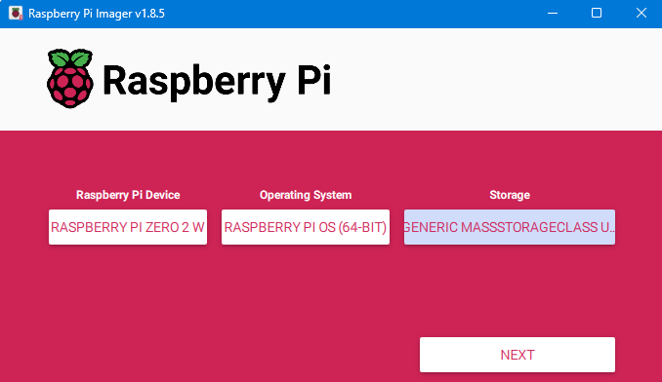

Edit Settings YES
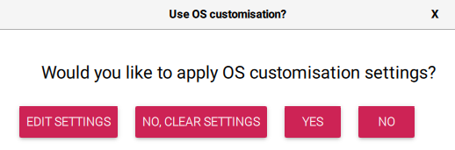
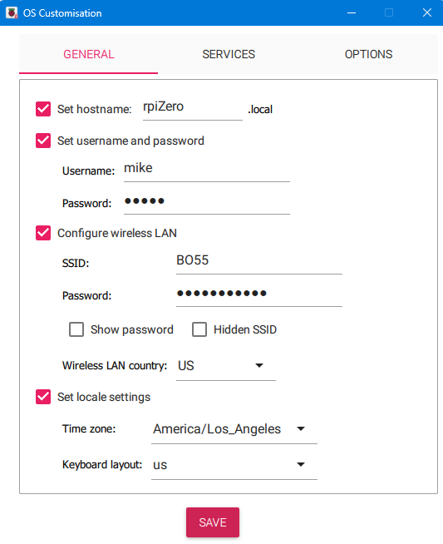
Follow these instructions for Headless VNC:
https://www.nikouusitalo.com/blog/how-to-run-a-raspberry-pi-zero-2-w-headless/

